RESEARCH DOCUMENT
Traditional Indian Games of Tamil Nadu
Kattam Vilayattu & Paramapadam

A Comprehensive Study of History, Culture & Gameplay

March 2026
Krida Game Catalog Research Series

■ PART I: KATTAM VILAYATTU
கட்டம் விளையாட்டு — The Square Game of Tamil Nadu

1.1 Game Overview
Kattam Vilayattu, literally meaning "Square Game" in Tamil, is one of the oldest and most beloved traditional board games of Tamil Nadu, South India. Also known as Siru Kattam ("Small Square Game") or Chaar Goti in some regions, it is an elegant alignment game that bears striking similarity to the modern game of Tic-Tac-Toe, but with added depth and strategic complexity. The game is played on a grid board with intersecting lines including diagonals, and each player strives to align their pieces in a winning formation before their opponent does.
The game has survived centuries of social change and continues to be manufactured and played in Tamil households, temple courtyards, and schools. Its simplicity makes it accessible to all age groups while its strategic demands keep it intellectually stimulating. Kattam Vilayattu comes in three progressive levels, each featuring a larger grid and greater challenge, from the basic 3×3 grid (Level I) to the complex 4×4 (Level II) and 5×5 (Level III) grids.

Other Names | Siru Kattam, Chaar Goti, Square Game, Noughts & Crosses (Tamil version)
Tamil Script | கட்டம் விளையாட்டு
Origin | Tamil Nadu, South India
Period | Ancient (exact date unknown; played for at least several centuries)
Players | 2 players
Game Type | Alignment / Strategy Board Game
Materials | Handcrafted wooden or cloth board; smooth stone or wooden coins
Levels | 3 (Level I: 3×3 | Level II: 4×4 | Level III: 5×5)
Build Effort | Low to Medium

1.2 History & Origins
The exact origins of Kattam Vilayattu are lost in the mists of antiquity, but historians and game researchers categorise it as an ancient alignment game, a genre with one of the longest histories in human civilisation. Grid and alignment games have been played across the world since prehistoric times, and India has its own rich tradition within this genre. In Tamil Nadu, alignment games were a staple of community life, with boards often drawn in the earth, on temple floors, or on cloth for portability.
Kattam Vilayattu belongs to the broad family of three-in-a-row games, cognates of which appear across ancient Egypt, Rome (Terni Lapilli), China, and indigenous cultures worldwide. The Tamil version, however, is uniquely distinguished by its use of multi-level grids with integrated diagonal connections following the kolam (rangoli) drawing tradition — a fact that sets it apart as a culturally specific development rooted in South Indian artistic and intellectual heritage.
Traditional game researchers classify Kattam Vilayattu as an "alignment game," alongside other Indian games like Nava Kankari (Nine Men's Morris). The Tamil Nadu Handicraft Artisans' community has long crafted these boards by hand, passing down the tradition through generations. Modern revivals by cultural preservation organisations and commercial manufacturers have brought renewed attention to this game.

1.3 Cultural Significance & Links
Connection to Kolam Art
One of the most striking features of Kattam Vilayattu is its visual connection to kolam, the traditional art form practiced by Tamil women who draw intricate geometric patterns at doorsteps every morning. The board itself, with its grid of dots connected by lines, mirrors the structure of a kolam pattern — specifically the pulli kolam (dot-based kolam). This is not coincidental: both the game board and the kolam are expressions of the same mathematical and aesthetic sensibility that has characterised Tamil culture for millennia.
In communities across Tamil Nadu, women who were adept at kolam drawing were considered naturally talented at Kattam Vilayattu because the same spatial reasoning and pattern recognition required to draw a kolam is also required to master the game. The animated board-drawing of a kolam before the game begins has been identified as a key design opportunity for digital versions of the game.
Social & Pedagogical Role
Kattam Vilayattu has historically been used as both an entertainment and an educational tool. Playing the game mentors several cognitive skills including dynamic thinking, strategic planning, tactical analysis, anticipating the opponent's moves, and concentration. Because the game is simple to understand but difficult to master, it has traditionally been introduced to children as young as five years old, then progressively challenged with higher levels as their skills grow.
The game was also a social equaliser — requiring no expensive materials, it could be played anywhere, from palace courts to village courtyards. Seeds, pebbles, tamarind seeds, and conch shells have all historically served as game pieces, making it a truly democratic pastime that crossed caste and class lines.
Preservation & Revival
As with many traditional games, Kattam Vilayattu faced decline during the 20th century as electronic games and urban lifestyles displaced community-based play. However, cultural preservation efforts by organisations such as the Centre for Contemporary Folklore (CCF), Tamil Nadu Handicraft Artisans cooperatives, and commercial sellers like NMK Online have successfully revived interest in the game. It is now available as a handcrafted product made by Tamil Nadu artisans, packaged in eco-friendly materials and marketed nationally and internationally.

1.4 The Game Board
The traditional Kattam Vilayattu board consists of a grid of dots (points) connected by horizontal, vertical, and diagonal lines, drawn on cloth, wood, or stone. The three levels differ in grid size:
- Level I — 3×3 grid: 9 intersection points. Each player has 3 pieces. Simpler and faster, ideal for beginners.
- Level II — 4×4 grid: 16 intersection points. Each player has 4 pieces. Requires deeper strategy.
- Level III — 5×5 grid: 25 intersection points. Each player has 5 pieces. Complex, longer game with multiple tactical layers.
The boards are typically 9×9 inches and made from handcrafted wood or durable canvas. Pieces are smooth stones or wooden coins — two sets of different colours (traditionally green and brown) to distinguish the players.

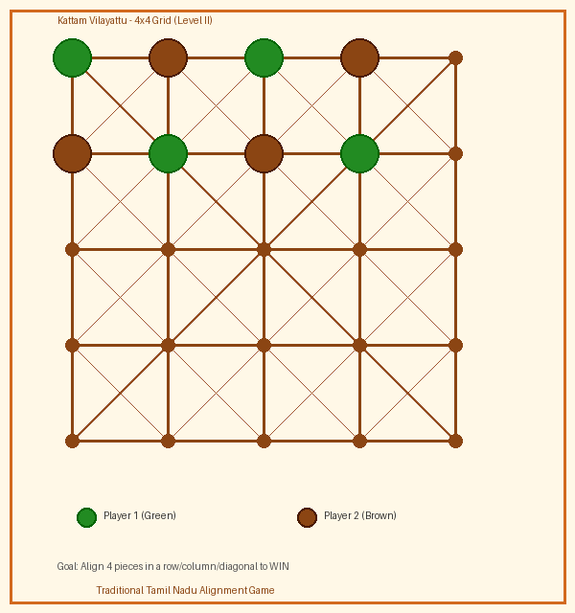
Figure 1: Kattam Vilayattu — 4×4 Grid Board with Sample Piece Placement (Level II)

1.5 Rules of the Game
Objective
The goal of Kattam Vilayattu is to align a specified number of your own pieces in a straight line — either horizontally, vertically, or diagonally — before your opponent does. In Level II (4×4), the objective is to align 4 pieces in a row.
Setup
- Place the board on a flat surface between the two players.
- Each player receives their set of coloured pieces (e.g., green and brown).
- Decide who plays first, typically by tossing a coin or mutual agreement.
Phase 1 — Placement Phase
- Players take turns placing one piece at a time on any unoccupied intersection point on the board.
- Continue until all pieces have been placed on the board.
- If any player achieves the winning alignment during the placement phase, that player wins immediately.
Phase 2 — Movement Phase
- Once all pieces are placed, players take turns moving one piece at a time along any line (horizontal, vertical, or diagonal) to an adjacent unoccupied point.
- A piece may only move to a directly connected adjacent point.
- The player who first achieves the winning alignment of all their pieces in a row wins the game.
Winning Condition
A player wins when they successfully place or move all their coloured pieces into a single straight line (a row, column, or diagonal) on the board. This line must encompass all the player's pieces simultaneously.
Tips & Strategy
- Opening move: Placing your first piece on a corner point is strategically advantageous, giving you control over two diagonal lines.
- Block your opponent: Anticipate where your opponent is building a line and block it before they complete it.
- Fork strategy: Try to create two possible winning moves at once, forcing your opponent to defend only one.
- In the movement phase, prioritise pieces that are most isolated from the target alignment.

■ PART II: PARAMAPADAM
பரமபதம் — The Sacred Tamil Snakes & Ladders

2.1 Game Overview
Paramapadam (Tamil: பரமபதம்) is the Tamil name for the ancient Indian board game known across the country as Moksha Patam, Gyan Chauper, or Vaikuntapali. In English, it evolved into the globally popular Snakes and Ladders. The name Paramapadam literally translates as "Supreme Position" or "the Highest Place" — a direct reference to Vaikuntam, the celestial abode of Lord Vishnu in Vaishnava theology. The game is a profound allegory of the human soul's journey through life, with ladders symbolising virtuous deeds and merit (punya) and snakes representing vices and sins (paavam) that drag one downward.
Unlike the modern commercial version of Snakes and Ladders which is purely a game of chance, the traditional Paramapadam is steeped in theological and philosophical meaning. Each square, snake, and ladder on the authentic Tamil board is associated with specific virtues, vices, deities, or spiritual states drawn from Vaishnava iconography and the Bhagavata Purana. The game is not merely entertainment — it is a teaching tool, a meditation aid, and a ritual practice observed during the sacred night of Vaikunta Ekadasi.

Other Names | Moksha Patam, Vaikuntapali, Paramapada Sopanam, Saanp aur Seedhi, Snakes & Ladders
Tamil Script | பரமபதம்
Origin | Tamil Nadu / South India (with parallel versions across India)
Period | Bhakti Period (c. 1000 CE); ancient roots may be older
Players | 2 to 6 players (traditionally 2–4)
Game Type | Race / Morality / Luck-based Board Game
Materials | Board with 100 (or 132) numbered squares; brass dice (Dhaayakattai); wooden/seed pieces
Festival Link | Vaikunta Ekadasi (December) — played overnight in temples
Build Effort | Medium (code shares ~90% with Moksha Patam)

2.2 History & Origins
Paramapadam has roots that stretch back at least to the 13th century CE. Historians attribute the formalisation of this moral board game to the tradition of Vaishnava Bhakti saints, with the game designer credited by some sources as a figure from the Bhakti movement. The game was called Moksha Patam ("Cloth of Salvation") in its original Sanskrit-influenced form, reflecting its primary purpose as a teaching aid for moral and spiritual instruction.
Paramapadam is played since the Tamil epic period and carries spiritual lessons about the soul's journey through life. In Tamil temple tradition, the game was associated with Vaikunta Ekadasi — the holiest night of the Vaishnava calendar — when devotees in Tamil Nadu stay awake all night in temple courtyards, playing Paramapadam to remain vigilant and spiritually focused as they await the opening of the Paramapada Vasal (the Gateway to Heaven) at the temples of Lord Vishnu.
The game is also described in Swami Desikan's "Paramapada Sopanam," a 14th-century Vaishnava philosophical text that uses the metaphor of the game’s nine steps to describe the soul's ascent to Paramapadam (the divine abode). This literary connection gives the game extraordinary cultural depth — it is one of very few board games to be simultaneously a philosophical treatise, a religious ritual, and a popular pastime.
The British colonial administration encountered this game in India and adapted it as "Snakes and Ladders" in the late 19th century, stripping away its theological content and exporting it globally. The modern commercial version retains the mechanical structure but has lost the spiritual symbolism of the original.

2.3 Cultural Significance & Links
Theological Foundation
The authentic Paramapadam board is a theological map of the cosmos in Vaishnava belief. Square 1, the starting point, represents Patalam (the Underworld) — the condition of a soul bound by ignorance and sin. Square 100, the final destination, represents Vaikuntam — the eternal abode of Lord Vishnu, the supreme goal of all souls. The journey from Square 1 to Square 100 represents the soul's pilgrimage through multiple lives and rebirths.
On the traditional Tamil Paramapadam board, each square from 1 to 100 carries a specific moral or theological meaning derived from the Bhagavata Purana and Vaishnava scripture. The snakes represent specific sins and vices: pride, anger, greed, deceit, and attachment. The ladders represent virtues and spiritual disciplines: compassion, devotion, charity, knowledge, and surrender to God (Saranagati in Vaishnava theology).
The Vaikunta Ekadasi Tradition
The most extraordinary cultural link of Paramapadam is its connection to Vaikunta Ekadasi, observed on the 11th day (Ekadasi) of the bright fortnight of the Tamil month of Margazhi (December–January). On this night, Vaishnavite temples across Tamil Nadu — including the Sri Ranganathaswamy Temple in Srirangam and Tirumala Tirupati — open the Paramapada Vasal (Gateway to Heaven) for devotees.
Devotees who wish to stay awake throughout the night play Paramapadam in the temple courtyards. Playing the game is considered a form of devotion and vigilance (jaagranam). Each roll of the dice is accompanied by the recitation of divine names ("Ranga! Ranga!" or "Narayana!"), and the gameplay becomes a meditation on the soul's journey. The game thus occupies an utterly unique position in world game history: it is the only board game in existence that is tied to a specific religious festival night as a prescribed ritual practice.
Philosophical Meaning
The Paramapadam represents the human condition with profound simplicity. The dice roll represents karma — the consequences of one's past actions, over which no individual has complete control. The snakes represent how one moment of moral failure can undo years of spiritual progress. The ladders represent how acts of virtue and devotion can rapidly elevate the soul. The game teaches that although chance (divine grace) plays a role, consistent virtue and devotion are the most reliable path to salvation.
The philosophical message resonates powerfully: "Some of it is based on chance, others give you the awareness in life to come out of all struggles, and to come out of it we need the Guru's guidance and God's grace."

2.4 The Game Board
The traditional Paramapadam board consists of 100 numbered squares arranged in a 10×10 grid. The numbering begins at Square 1 in the bottom-left corner and proceeds in a boustrophedon (alternating left-to-right, then right-to-left) pattern row by row up to Square 100 at the top. Squares are typically decorated with Vaishnava imagery, dashavatara (ten avatars of Vishnu) motifs, temple architecture, and scenes from the Bhagavata Purana.
Traditional boards were hand-painted on cloth or silk fabric, with each square containing beautiful miniature illustrations. The brass dice (Dhaayakattai), typically two elongated hollow brass bars with numbered faces, add to the authentic sensory experience of the game. Game pieces (kaayi) were traditionally seeds, cowrie shells, or wooden tokens.

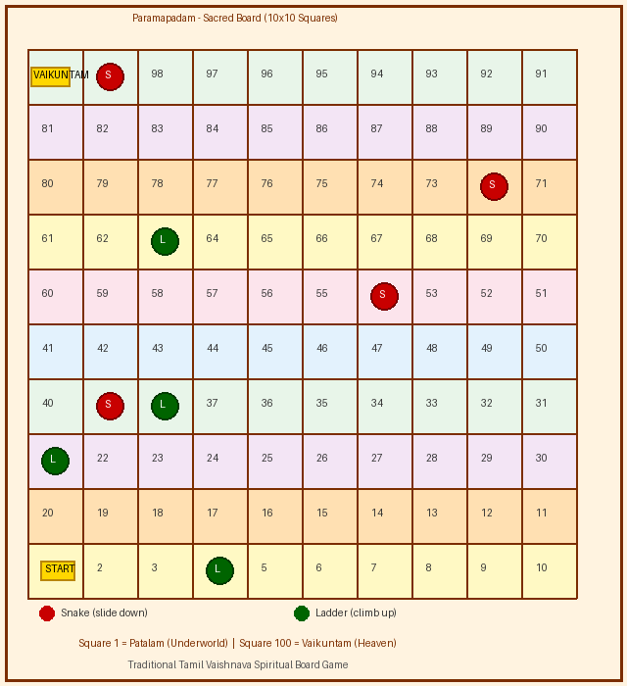
Figure 2: Paramapadam — 10×10 Sacred Game Board (S = Snake Head, L = Ladder Bottom)

2.5 Rules of the Game
Objective
The goal of Paramapadam is to be the first player to move their game piece from Square 1 (Patalam) to Square 100 (Vaikuntam) by navigating snakes and ladders along the way.
Setup
- Lay the Paramapadam board on a flat surface. All players place their pieces at the starting position (before Square 1, or at Square 1).
- Each player chooses a unique game piece (seed, shell, or wooden token) to distinguish it from others.
- The youngest player (or any agreed player) takes the first turn.
Gameplay — Turn by Turn
- The game begins only when a player rolls a 1 on the dice (in some versions, any number starts the game; check the specific board's rules).
- On each turn, the player rolls the brass dice and moves their piece forward by the number shown.
- If a player rolls a 6 (or 12 in some versions), they receive an additional bonus turn.
- When a player's piece lands on the bottom of a ladder, they immediately climb to the square at the top of the ladder — representing the reward of virtue.
- When a player's piece lands on the head of a snake, the piece slides down to the square at the tail of the snake — representing the consequence of sin.
- A player cannot go beyond Square 100; they must roll the exact number needed to land on it. Any excess is counted backwards.
- The first player to land exactly on Square 100 (Vaikuntam) wins the game.
Special Rules (Traditional Tamil Version)
- Rolling a 1 is required to enter the game (place the piece on Square 1).
- When a player climbs a ladder, they receive an additional turn.
- When a player is bitten by a snake, they do NOT receive an additional turn.
- In the traditional temple-night version, divine names are chanted with each dice roll.
- The game may be played by 2 to 6 players; with more players, the social and unpredictable nature increases.
Spiritual Variant (Vaikunta Ekadasi)
In the traditional overnight temple-courtyard version, players recite "Narayana! Narayana!" before each dice roll. The game proceeds slowly and meditatively throughout the night, with each snake and ladder being explained in its theological context by an elder or priest. The game ends at dawn when the Paramapada Vasal opens at the temple, and everyone proceeds for darshan (a sacred viewing of the deity).

■ CONCLUSION
Kattam Vilayattu and Paramapadam represent two distinct yet equally profound dimensions of Tamil Nadu's rich gaming heritage. Kattam Vilayattu exemplifies the intellectual and aesthetic tradition of alignment games — a tradition that finds its visual poetry in the kolam patterns drawn at every Tamil doorstep. Its three progressive levels make it as accessible to a five-year-old beginner as it is challenging for a strategic adult mind.
Paramapadam, on the other hand, stands as one of the most extraordinary board games in human history — a game that is simultaneously a theological map, a philosophical teaching, a ritual practice, and a social pastime. Its connection to Vaikunta Ekadasi gives it a living cultural context that has survived over a thousand years of social change. The game's export to Britain and its global spread as "Snakes and Ladders" is a testament to the universal resonance of its core metaphor, even as the spiritual depth was stripped away in translation.
Both games deserve to be played, studied, preserved, and passed on to future generations. They are not relics of the past but living traditions that connect contemporary players to centuries of Tamil wisdom, artistry, and spirituality. Their revival — through handcrafted board production by Tamil Nadu artisans, inclusion in cultural education programs, and digital adaptation — is both a preservation imperative and a gift to the world.

■ REFERENCES
- Centre for Contemporary Folklore (CCF). (2025). Traditional Games of Tamil Nadu. https://centreforcontemporaryfolklore.org/
- Tamil Nadu Tourism. Paramapadham. https://www.tamilnadutourism.com/traditions/games/paramapadham.php
- NMK Online. Kattam Vilayattu — Ancient Games Collection. https://nmkonline.com/
- Kreedaa Kaushalya Blog. Traditional Board Games of India: Introduction. http://kreedaakaushalya.blogspot.com/
- The Verandah Club. The Paramapadham. https://theverandahclub.com/article/the-paramapadham-34
- Aanmeegam. Vaikunta Ekadasi — Significance & Fasting Rules. https://aanmeegam.org/
- Commonwealth Union. Vaikunta Ekadasi: Why Hindus play Paramapadam on this day. (December 2025)
- Kavade. Kattam Vilayattu Level 1 — Product Description. https://kavade.org/product/kattam-vilayattu-level-1/
- Amazon India. Marutham Kattam Vilayattu Level III. https://www.amazon.in/
- Quora. What are some disappeared traditional games in Tamil Nadu? https://www.quora.com/
- Zupee Blog. Indian Board Games: 10 Ancient Board Games from India. https://blogs.zupee.com/indian-board-games/

